

SMALL BUSINESS SIZE STANDARDS SOLUTIONS SUMMIT
March 4, 2011
8:30 am – 4:45 pm

7:30 Registration & Networking
8:30 Opening Remarks & Introductions
8:45 Importance of Seminar – Major Clark, Assistant Chief Counsel for Procurement, Office of Advocacy, US Small Business Administration
9:15 Size Standards Background/History & Present Status – Pamela Mazza, Managing Partner, PilieroMazza PLLC
9:50 Break
10:00 SBA’s Size Standards Objectives – Khem Sharma, Chief, Office of Size Standards, US Small Business Administration
10:30 Panel: Challenges in Operations under Existing Size Standards
Richard Hernandez, e-MBE.net
Shiv Krishnan, Indus
David Rinaldo, Rock Creek Strategic Marketing
11:45 Mauricio Vera, Chair, Federal OSDBU Directors Interagency Council
11:50 The Jobs Act: What’s in it? Calvin Jenkins, Deputy Associate Administrator for Government Contracting & Business Development, US Small Business Administration
12:00 Lunch
12:30 Lunch speaker – Angela Styles, head of the Government Contracts group, Crowell & Moring, and former Administrator, Office of Federal Procurement Policy, OMB
1:10 Break
1:20 Introducing the Solutions Process – Fernando Galaviz and Jonathan Galaviz
1:40 Plenary: Open opportunity to submit fresh, workable solutions to improve the Size Standards regulations – Steve Kong
2:15 Group Workshops: Solutions focus groups to flesh out workable, implementable solutions
4:15 Wrap-up – Dan Heath. Charge to workgroups to return with realistic, workable, implementable solutions in three weeks.

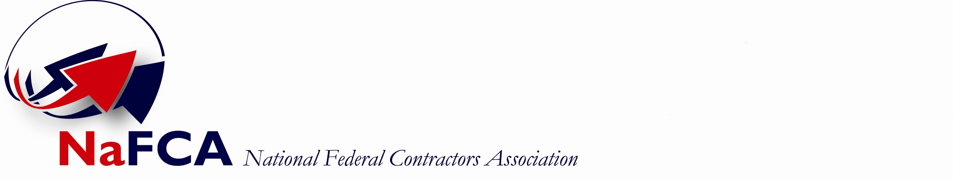

Small Business Size Standards Solutions Summit: Services Industries

Summit Workgroup Follow-up Sessions
And Final Solutions Breakfast

Follow-Up I (Week 3) – Groups will refine proposed solutions

Group 1 – Wednesday, March 23
Group 2 – Thursday, March 24
Group 3 – Friday, March 25

Follow-Up II (Week 5) – Groups develop solutions presentations

Group 1 – Wednesday, April 6
Group 2 – Thursday, April 7
Group 3 – Friday, April 8

These two Follow-Up meetings will be held in the
Building conference room at 6402 Arlington Blvd,
Falls Church VA 22042

Final Solutions Breakfast ( Week 9) – Wednesday, May 4

Fairview Park Marriott
3111 Fairview Park Dr
Falls Church VA 22042

