ISSUE
STEADY SQUEEZING OUT OF MID-TIER COMPANIES

POSITION
MTA believes it is time for Congress to recognize the shrinking Mid-tier government contracting community by modifying the NAICS codes to allow small firms to grow and mature.
The U.S. Small Business Administration (SBA) will not realize the full potential of its $112M in “Contractor Assistance”, because NAICS code ceilings circumvent and inhibit the realization of a return on this investment. Not only do the NAICS code ceilings prevent the full ROI on SBA’s and taxpayer investment, but small businesses operating in the federal space are sometimes forced to artificially limit their revenues to remain in the small business classification.

The U.S. Small Business Administration (SBA) budget for 2011 is $994M. Of that amount, eleven percent (11%) or $112M is spent on “Contracting Assistance”, which includes 8(a), prime and subcontracting assistance, and HUBZone programs. These monies are in addition to the expenditures on “technical assistance” and loan programs. The investment pays off as long as small businesses remain small as defined by the SBA and the Office of Management and Budget.

It is the role of SBA to “grow businesses and create jobs by providing resources and tools, including access to capital; opportunities in federal contracting; access to entrepreneurial education; and disaster assistance for businesses…”, and they do an excellent job of this… as long as a business is classified as small (SBA Budget, 2011). Small businesses that grow beyond the limits set by the NAICS codes are in fact punished for doing what any business aims to do and that is to grow (Galaviz, 2010).

Unfortunately, the SBA only recognizes two categories of business---small and large, and according to SBA, their “authority is limited to helping small businesses. Once a business is no longer small, they are not eligible for SBA assistance”. (Johns, 2010) Consequently, once a small business providing services in an industry code (i.e., training) with a $7M NAICS ceiling exceeds the limit, it is no longer classified as small, but it is definitely not large enough to compete on the full and open markets with billion dollar firms. Consequently, a business is faced with few choices including 1) sell the business; 2) subcontracting only; 3) compete with billion dollar firms.

The SBA acknowledges that one of the reasons why firms go out of business is “reduced federal contracting opportunities” (Johns, 2010). The primary reason why a small firm would have “reduced federal contracting opportunities” is because it no longer meets the definition of a small business. Therefore, it is not qualified to bid on small business set-asides; large firms do not get credit for subcontracting to them; and, the small firm cannot compete on the full and open market.

There is a built-in prejudice against small businesses that grow beyond the NAICS ceilings. The belief is that a small business in industry code 541511, Custom Computer Programming Services, is no longer in need of assistance when its revenues exceed $25M. In reality, that firm has grown and developed to the point that it is too big to be small and too small to be big. It no longer qualifies for small business set-asides, and it cannot compete with billion dollar firms.

The solution is for the federal government to recognize that there are more than two types of businesses. At a minimum, there are three levels: small, mid or second tier, and large.

The Center for Strategic and International Studies (CSIS) did a study of the Federal Professional Services Industry from 1995-2007. One of the study results showed that there is a “steady squeezing out of mid-tier companies”. This squeeze comes from above (consolidation of both industry and requirements (i.e., contract bundling)) and from below (small-business set asides.) (Berteai, Bem-Ari, and Sanders, 2007)

The study states that “it is clear that middle-tier companies have suffered a significant erosion of their relative share.” Small-business set-aside laws and other policies protecting small firms have clearly worked in the professional services industry. Small companies have sustained a 19–21 percent market share in the value of prime contracts (their share of the market is larger if the value of subcontracts is included). The large companies in this industry have been particularly active via mergers and acquisitions and have been able to increase their market share from 37 to 46 percent. Thus, the middle tier has been squeezed from above by consolidation and from below by small businesses holding on to their share of the market. Furthermore, it seems that as a result of this trend, medium-sized companies are beginning to opt out of the federal professional services market. The data show that in the past two years there has been a drop of between 1 and 6 percent in the number of medium-sized companies undertaking significant contracts (those worth $25,000 or more) in all sectors of the professional services industrial base (with the exception of the ICT sector).

Figure 1. Market shares by large, medium, and small firms
(by value of contract actions, selected years)
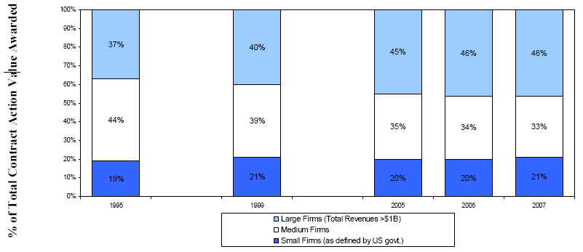
Source: Federal Procurement Data System, CSIS analysis

In addition to the shrinkage shown in Figure 1 above, MTA and Rand believes that the $100B budget cuts in the DoD will further constrict opportunities available to small businesses. “As a result, in future years, should weapon system procurement increase relative to other spending, as it is currently projected to do, the small-business share of overall DoD purchases is likely to diminish. (Moore, DaVanzo, et al, 2008)

MTA strongly believes it is time for Congress to recognize the shrinking Mid-tier government contracting community by modifying the NAICS codes to allow small firms to grow and mature.

References

Berteai D. Bem-Ari G, Sanders G. Structure and Dynamics of the U.S. Federal Professional Services Industrial Base 1995–2007. Center for Strategic and International Studies, Defense Industrial Initiatives Group. 2007 [cited 20 Oct 2010]
Available from : http://csis.org/files/media/csis/pubs/090212_fps_report_2009.pdf

Galaviz, Fernando. Congressional testimony given on behalf of the Mid-Tier Advocacy group before the Subcommittee on Government Management, Organization, & Procurement of the House Oversight and Government Reform Committee. Hearing entitled: September 22, 2010 “Minority Contracting: Opportunities and Challenges for Current and Future Minority-Owned Businesses”. 22 September 2010

Johns, Marie. Deputy Administrator, US. SBA. Response to “questions for the record” posed by the Subcommittee on Government Management, Organization, & Procurement of the House Oversight and Government Reform Committee. Hearing entitled: September 22, 1010 “Minority Contracting: Opportunities and Challenges for Current and Future Minority-Owned Businesses”. Nov. 2010

Moore N, Grammich C, DaVanzo J, Held B, Coombs J, Mele J.Enhancing Small-Business Opportunities in DoD. Kauffman-Rand Reports [online]. Prepared for the Office of the Secretary of Defense. 2008 [cited 20 Oct 2010]
Available from: http://www.rand.org/pubs/technical_reports/2008/RAND_TR601-1.sum.pdf

United States Small Business Administration. FY 2011 Congressional Budget Justification AND FY 2009 Annual Performance Report. Web. 22 November 2010. http://www.sba.gov/idc/groups/public/documents/sba_homepage/fy_2011_cbj_09_apr.pdf

